Third eye website tips

**HOW TO ADD FONTS EASILY USING FONT FAMILY**

* How I connected treefrog
  + Open “C:\Windows\Fonts” and find treefrog
  + **Copied** main ttf file from into project file into a folder called “fonts” (second level)
  + 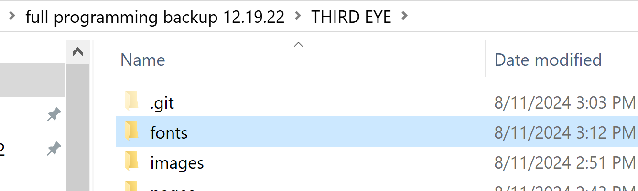
  + Linked it in css using font-family (just named it treefrog)

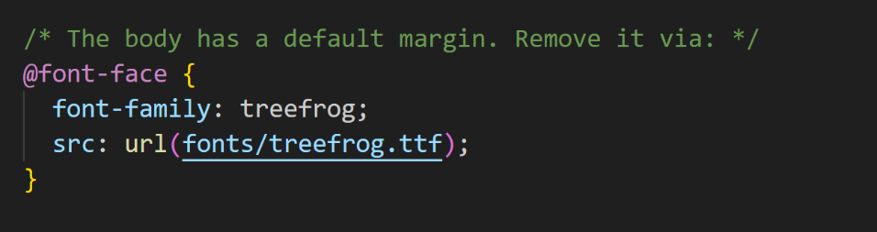

* + Then updated a css h3 attribute with treefrog
  + 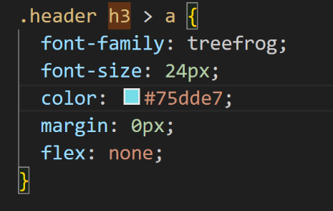
  + <https://www.pagecloud.com/blog/how-to-add-custom-fonts-to-any-website>



* ^^ updating a CSS property for one element within HTML (saves so much time)
* My website to comic tapas: <https://tapas.io/series/Third-Eye-SOAD>
* <https://cssgradient.io/>
* ^^ GRADIENT WORK
* <https://stackoverflow.com/questions/885835/position-an-image-outside-of-its-container>
* ^^ Positioning serj outside the flexbox div LOL
* <https://web.archive.org/web/19991013044623/http://systemofadown.com:80/fs.html>
* SOAD OLD HISTORIC FORUMMM >> CLICK ON LINKS>>>> THEN CLICK ON "free thinkers are dangerous"
* <https://www.youtube.com/watch?v=2KL-z9A56SQ>
* Heavenly super fast easy guide to media queries in CSS (aka how I mobile format)
* Making an image within a div fit to the div
* <https://github.com/Elegant-Geek/third-eye/commit/24bc66ace43551bd3a2292d16cf6375dc0f3bf64>
* 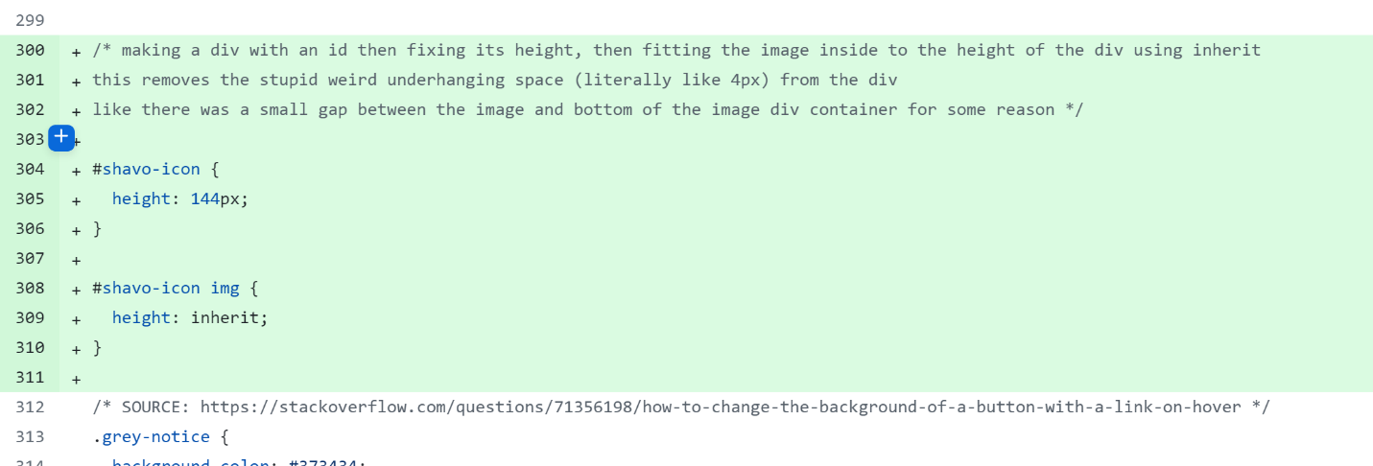
* BELOW HOWEVER IS A CAVEAT / EXCEPTION: if link (a is wrapped around / included with the image, ignore the stuff above.)
* 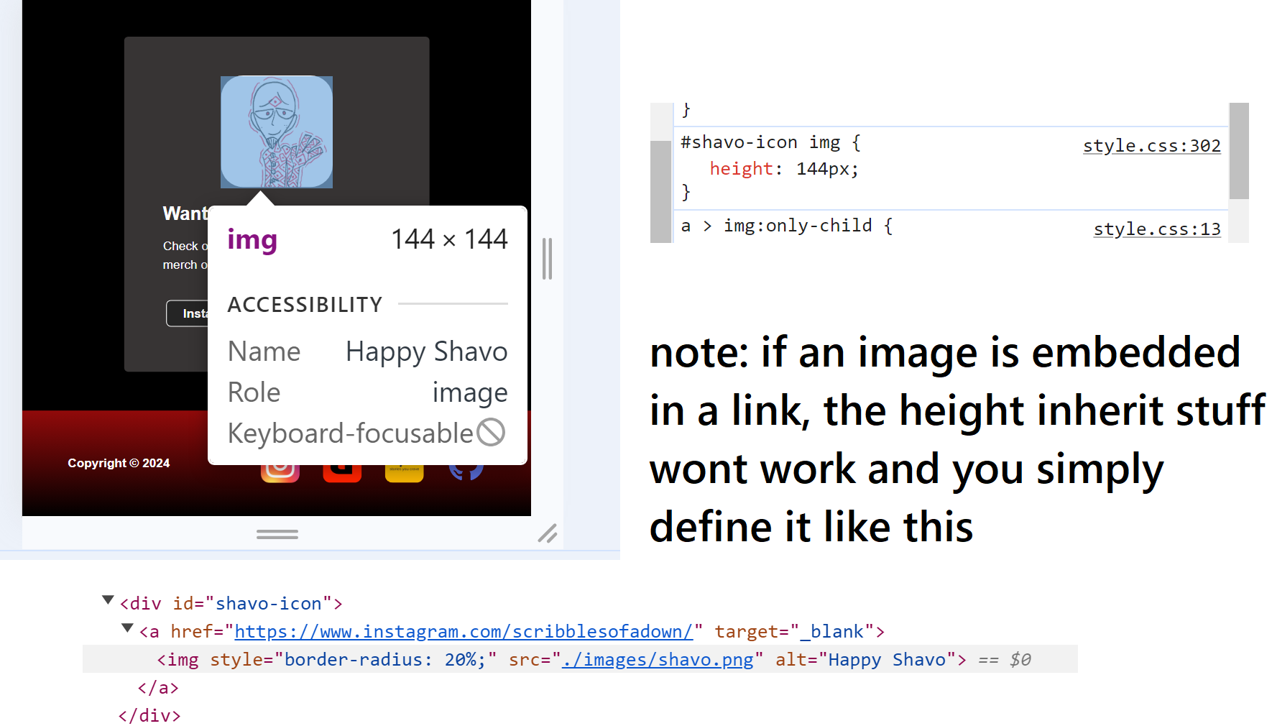
* Removing extra blue stuff from under an image with a link embedded
* 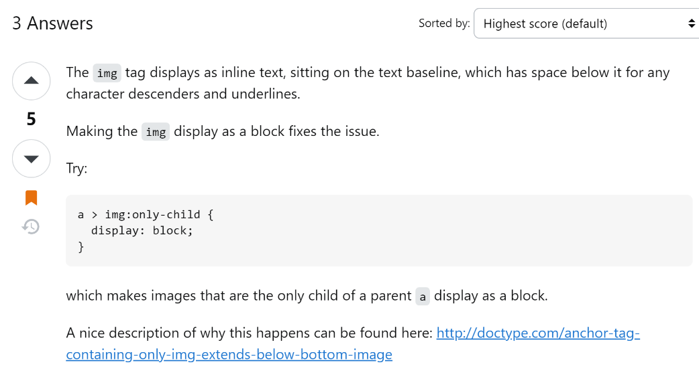
* <https://stackoverflow.com/questions/27698166/link-extends-to-space-outside-of-image>
* 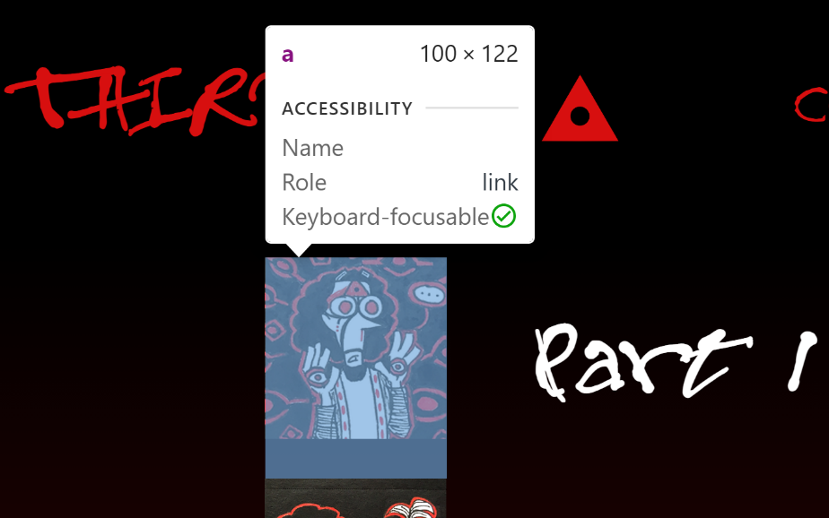 A black and red poster with a black background

  Description automatically generated with medium confidence
* BEFORE AND AFTER YAY

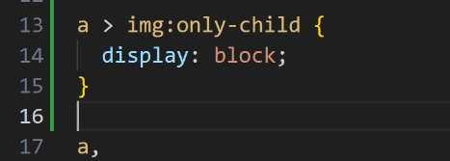

* ^^ just plopped this somewhere near the top of my css file yay
* Hey if you have black body like your footer has black space to the right its because you have a min width or max width of a div that exists to the point that forces stuff to sit or expand outside the main div container / body
* 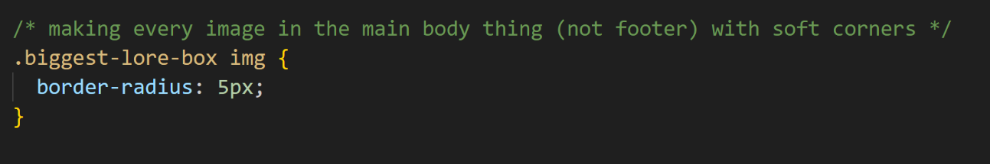
* REALLY efficient CSS ^

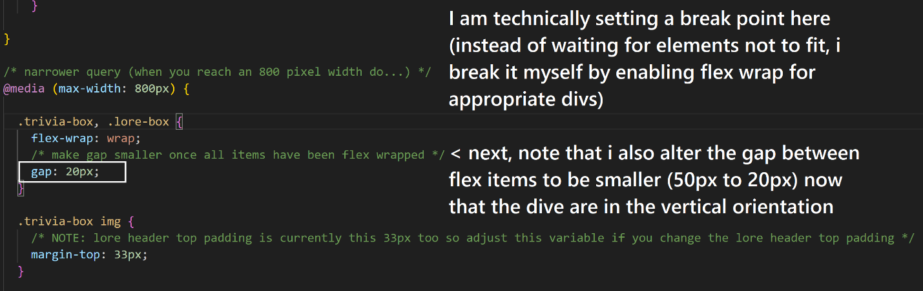

* Media query tip: setting up flex wrap when screen width reaches 800px so that elements will start to wrap )
* Also the very bottom line of code allows there to be more space above the images when they have wrapped because before they didn’t have any margin above to push away anything above it
* 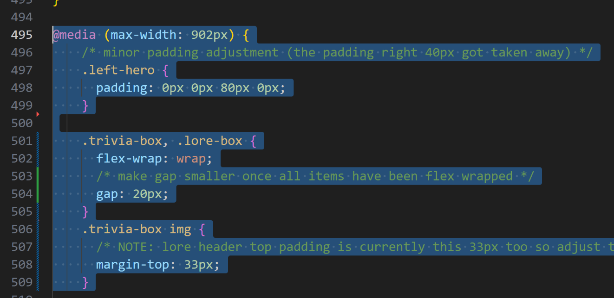
* Media queries for the lore page are amazing btw ^^
* TIP: an image with a link associated with it must be specified as .div img a {} in CSS not just .div img { }
* 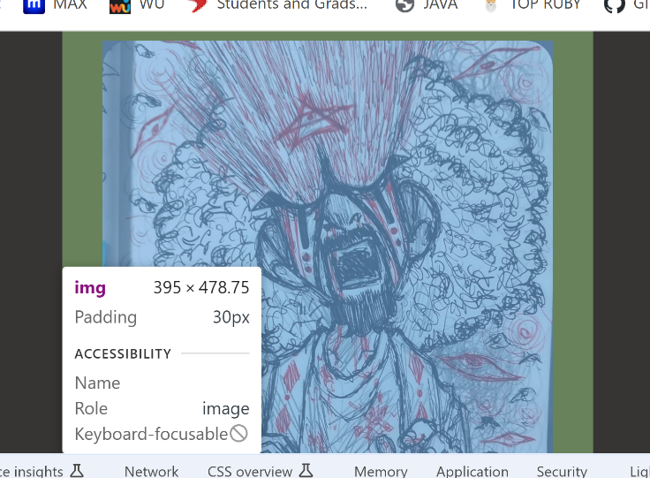
* 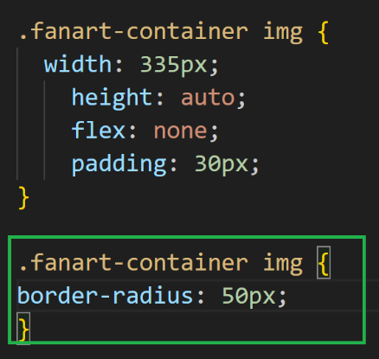
* Example I am setting a border radius here
* NOTE: IF YOU LIST YOUR MEDIA QUERIES NOT AT THE END OF YOUR CSS FILE THEN U RISK IT BEING OVERRIDDEN ACCIDENTALLY BY ANY CHANGES THAT ARE MENTIONED UNDERNEATH THOSE QUERIES UGH (css sheet reads from top to bottom)
* HOW TO PREVENT THIS INTERMEDIATE FLEX WRAP DURING A MEDIA QUERY! (currently paragraph padding is set to 16px on all sides when the media breakpoint is reached.)

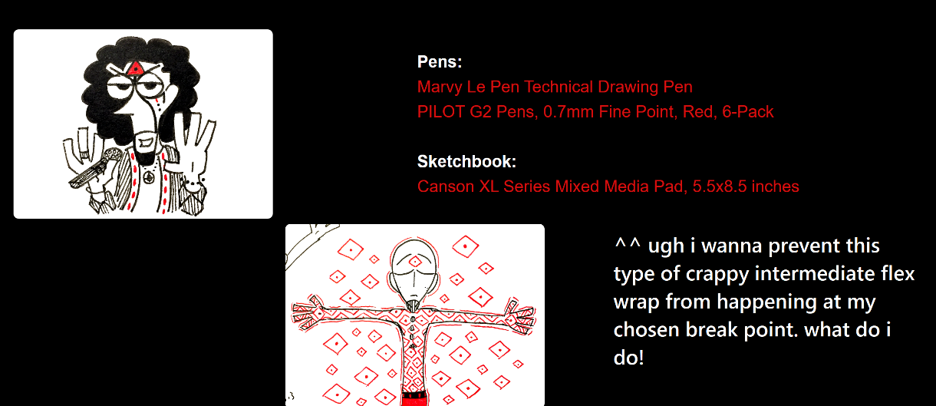

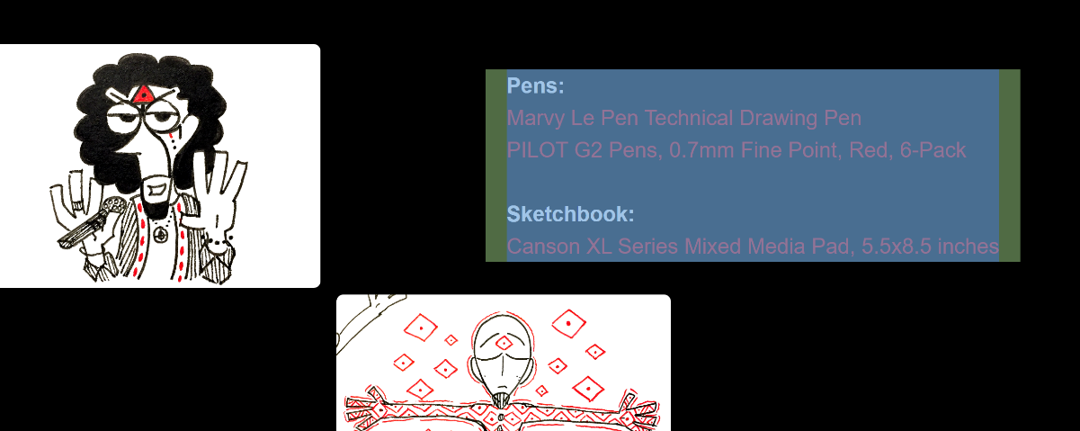

HOW TO FIX:

Assuming the paragraph text divs are not limited to a min width and allowed to fill the entire div, you can do this in the media query: add more side padding that is proportional to the vw to boot it out.

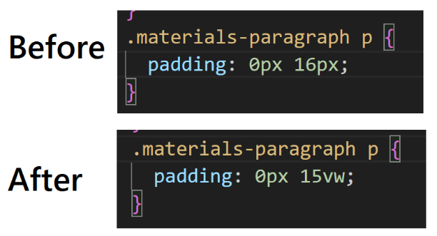

^^ TADAH end result!

Don’t forget when making a website to use lorem ipsum!!! Like just grab some lorem ipsum off a website generator and plug it into where you will have paragraphs!

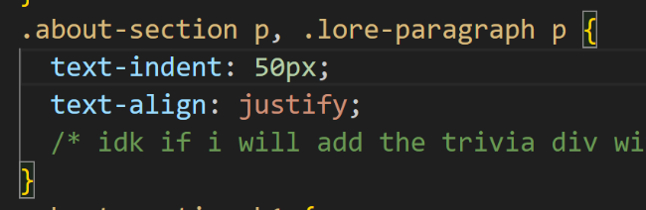

Another tip is to simplify code by applying the same styles to multiple classes ONCE so if an edit is made, you only need to tweak it in one place! (if a style only applies to one of these divs then you just do its own own separate class)

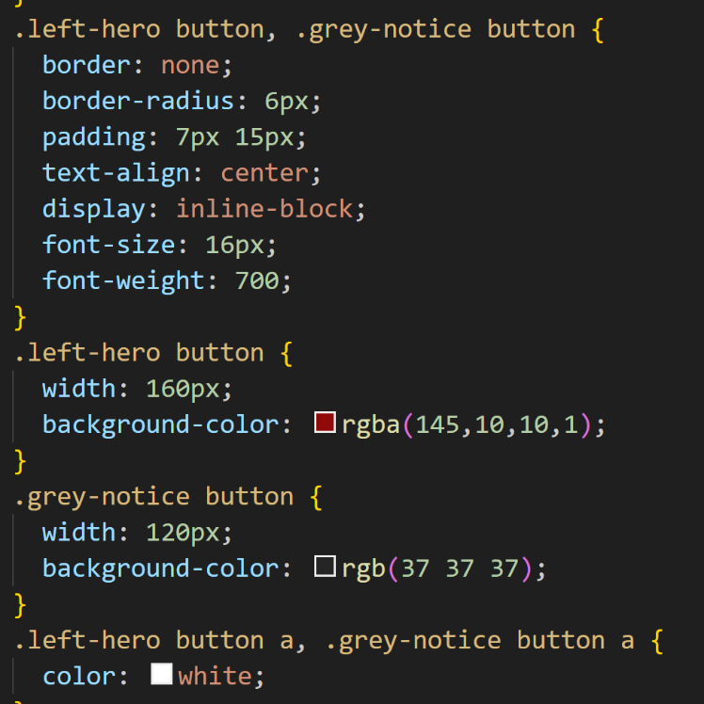

So see how the shared styles between the two classes are listed first followed by the individual / unique class styles for each class (.left-hero-button and then .grey-notice-button) respectively.

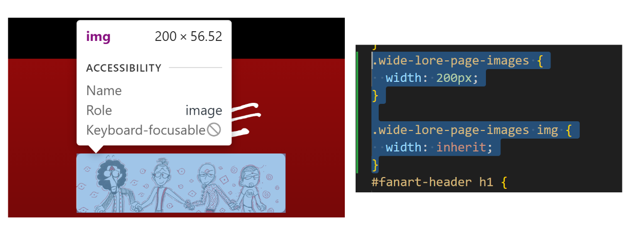

How to add image ^^^ and format its height using its parent div.

TIP in general! Play around with the desired effect you want using google chrome developer tools! Then after you are satisfied with that, then implement the styles in your css code. You know it worked if you refresh your google chrome page of your project and it stays the same (aka you updated your code to match the intended visual results of your tinkering on chrome)